Project 2 Part B document Template

Pre-Optimization:

1. Provide a graph of the dynamic instruction count for at least 5 sentences of varying length for Project 2 Part A Unoptimized Code.
   1. Lorem, ipsum.

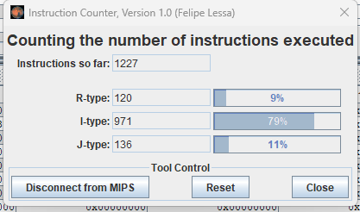

* 1. Lorem ipsum dolor sit.

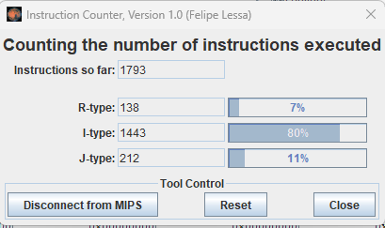

* 1. Lorem ipsum, dolor sit amet consectetur adipisicing elit.

* 1. Lorem ipsum dolor sit, amet consectetur adipisicing elit. Debitis eveniet est aliquid ipsum sed dignissimos laboriosam.

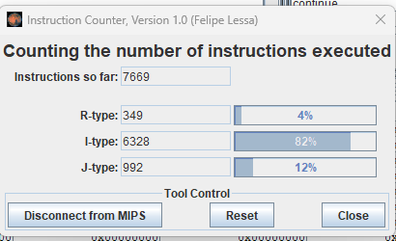

* 1. Lorem ipsum dolor sit amet consectetur adipisicing elit. Explicabo dolor quod optio totam quam, eaque accusantium deleniti tenetur ipsam vel. Similique, quae? Molestias fuga incidunt saepe sed? Similique eaque ipsum magnam culpa!.

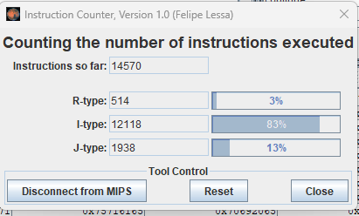

* 1. Graph of dynamic instruction count for sentences of 2, 4, 8, 16, and 32 characters in length. (please choose your own char count)

1. Provide calculations for the CPI of the above 5 sentences as well as a graph of their respective CPIs for Project 2 Part A Unoptimized Code.
   1. CPI Calculations for sentences of 2, 4, 8, 16, and 32 characters in length.
 $2.084759576$

     1. 2.035694367
      2. 1.986147412
      3. 1.961663841
      4. 1.937542896
   2. Graph of CPI for sentences of 2, 4, 8, 16, and 32 characters in length.
2. Calculate and plot a graph of Energy consumption for 5 different sentences of different lengths prior to optimization assuming ALU = 4 fj, Jump = 3 fj, Branch = 6 fj, Memory = 100 fj, and Other = 8 fj.
   1. Calculations of Energy Consumption for sentences of 10, 20, 30, 40, and 50 characters in length.
      1. 19695

* + 1. 29780

* + 1. 67101

* + 1. 121711

* + 1. 284723

* 1. Graph of Energy Consumption for sentences of 2, 4, 8, 16, and 32 characters in length.

Post-Optimization:

1. Optimize your code to consume less energy based on the above assumptions.
   1. Write about what was your strategy that you applied to reduce the energy consumption? And mention what was the reasoning behind choosing that strategy.
   2. Instead of using a loop to check KNIGHTS I unrolled the loop and avoided redundant checking of characters. And finally, reduced the number of checks per character.
   3. Re-calculate energy consumption for all sentences you choose after optimization.

* 1. 5492

* 1. 12549

* 1. 22555

* 1. 52914

* 1. Graph of Energy Consumption for Optimized Code

Calculate MIPS/mW for the optimized code for each of the 5 different sentences.